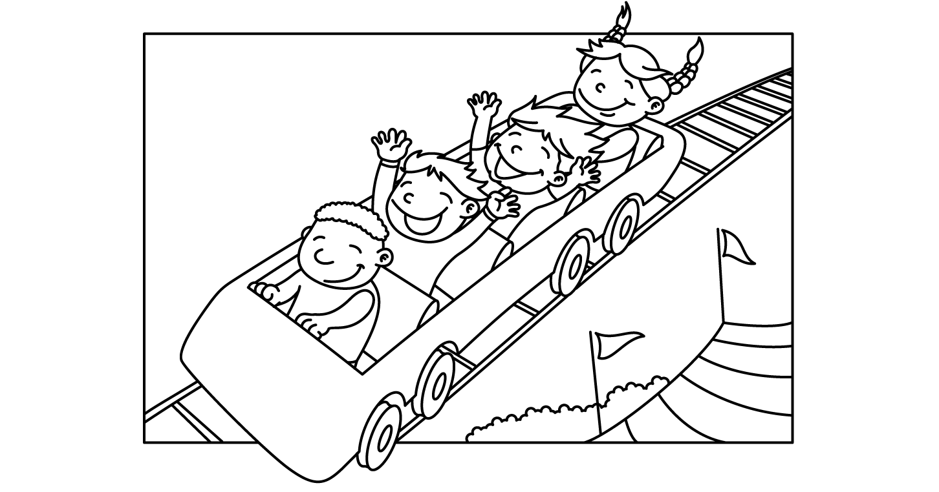

GBLNP JULY SUMMER CAMP 2014
Sunday | Monday | Tuesday | Wednesday | Thursday | Friday | Saturday
Theme:  Stars and Stripes |  | 1  Making our Flags | 2 | 3  Wear red, white and blue  (Flag parade) | 4  Center  Closed  4th of July | 5
6  Theme:  Zoology | 7 | 8 | 9  In house Field trip (petting zoo)  Pony rides | 10 | 11  Pizza day | 12
13  Theme:  Pirate Adventure | 14  Field Trip  Infants, toddlers and two’s  (chick-fil-a) | 15  Making a treasure map | 16  Treasure chest piñata’ | 17 | 18  Treasure Hunt | 19
20  Theme:  Creative Campers | 21  Camp fires | 22  Field Trip  Movies | 23  Making  s’mores | 24 | 25  Pajama Day | 26
27  Theme  Under the Big top | 28 | 29  Crazy Hair  Day | 30  Wacky Wednesday  Dress like a clown | 31
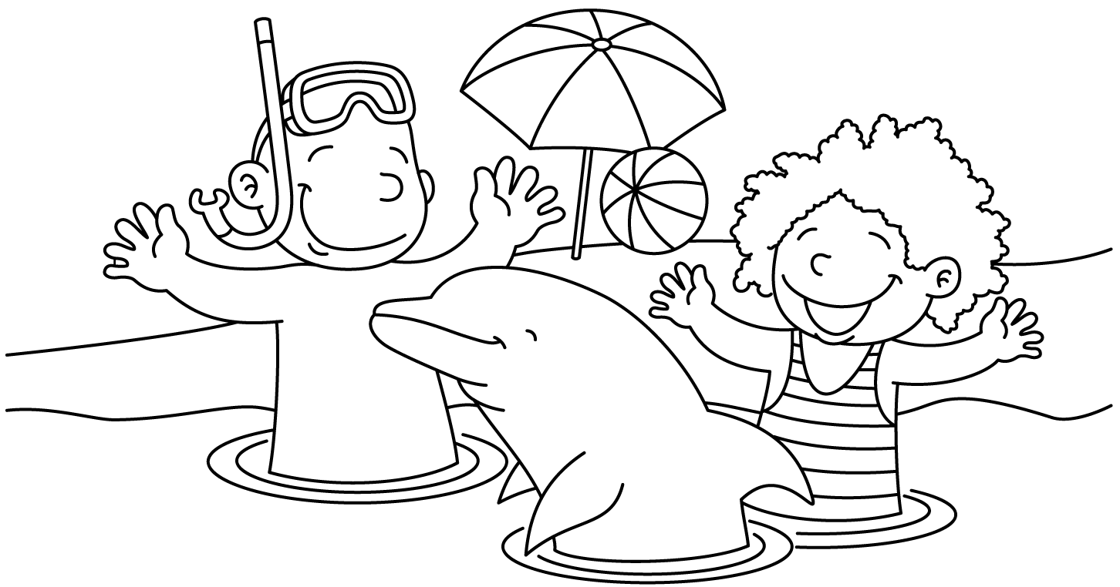

GBLNP AUGUST Summer Camp 2014
Sunday | Monday | Tuesday | Wednesday | Thursday | Friday | Saturday
Theme:  Under the big top (circus) |  |  |  |  | 1  Ms. Dee the  clown  (snow cones/cotton candy) | 2
3  Theme:  Olympic Week | 4 | 5 | 6  Field Trip  Bowling  (preschool- school aged) | 7 | 8  Relay Race | 9
10  Theme:  Splash week | 11 | 12  Picnic  (infants) | 13  Ice scream  social | 14 | 15  Water day | 16
17  Theme:  Hawaiian luau | 18  Field Trip  Laser tag  (school-aged) | 19 | 20  Pizza Day | 21 | 22  Family Day  Cook out  (Luau) | 23
24  Theme:  Back to School | 25  (parents)  Back to school night | 26 | 27 | 28 | 29 | 30

